# “ONLINE NWESPAPER DELIVERY MANAGEMENT SYSTEM”

**Advance Web Programming Project report**

**submitted**

**In the partial fulfilment the award of degree of**

**BACHELOR OF TECHNOLOGY**

**IN**

**COMPUTER SCIENCE AND ENGINEERING (2022-2023)**

**By**

**A. SRAVANTHI (211801370079)**

**A. RISHITHA (211801370065)**

**Under the esteemed Guidance of G. Rama devi, Asst .Professor**



**CENTURION UNIVERSITY OF TECHNOLOGY & MANAGEMENT**

**Vizianagaram, Andhra Pradesh**



**CENTURION UNIVERSITY OF TECHNOLOGY & MANAGEMENT**

**Vizianagaram, Andhra Pradesh**

# BONAFIDE CERTIFICATE

This is to certify that the project work entitled **“**ONLINE NEWSPAPER DELIVERY MANAGEMENT SYSTEM**”** is a fulfilment of project work done by **A Sravanthi (Regd.no:211801370079) A Rishitha (Regd.no:211801370065)** for the award the degree of **BACHELOR OF TECHNOLOGY** in **COMPUTER SCIENCE AND ENGINEERING,** during academic year 2022-2023.

**INTERNAL GUIDE HEAD OF THE DEPARTMENT**

**G. Rama Devi R.LAXMAN RAO**

**M.TECH,(Ph.D) M.TECH,(Ph.D)**

**Asst. Professor Asst. Professor**

**Dept. Of CSE Dept. Of CSE**

# ACKNOWLEDGEMENT

It is with at most pleasure and excitement we submit our project partial fulfilment of the requirement for the award of Bachelor of Technology.

The project is a result of the cumulative efforts, support, guidance, encouragement and inspiration from many of those for whom we must give our truthful honor and express gratitude through bringing out this project at the outset as per our knowledge.

We convey special thanks to our Project Guide **G. RAMA DEVI, M.Tech,(Ph.D)** Asst.Professor who has guided us and encouraged us to enhance our knowledge with present working of this project to enrich the quality of project.

We expressed our appreciation **to R. LAKSHMANA RAO, M.Tech,(Ph.D)** Asst.Professor and Head of the Department, who facilitated us to providing a friendly environment which helped to enhance our skills in the present project.

**Table of Contents**

Table of Figure(s)............................................................................................................................... 6

1. Introduction .................................................................................................................................. 7

1.1 Purpose ................................................................................................................................... 7

1.2 Scope....................................................................................................................................... 7

1.3 Definitions, Acronyms and Abbreviations................................................................................. 7

1.4 References............................................................................................................................... 7

1.5 Overview ................................................................................................................................. 8

2. Overall Description........................................................................................................................ 8

2.1 Product Perspective ................................................................................................................. 8

2.2 Product functions..................................................................................................................... 8

2.3 User Characteristics............................................................................................................... 8

2.4 User Constraints ............................................................................................................................ 9

2.5 Assumptions and dependencies......................................................................................... 9

2.6 Apportioning of Requirements........................................................................................... 9

3. Specific Requirements ................................................................................................................. 10

3.1 External interface................................................................................................................... 10

3.1.1 Web Server ..................................................................................................................... 10

3.1.2 PHP Application............................................................................................................... 10

3.1.3 MySQL Database ............................................................................................................. 10

3.2 Functional Requirements....................................................................................................... 10

3.2.1 Use Case Scenario ........................................................................................................... 10

3.3 Performance Requirements................................................................................................... 10

4 Requirement Specification............................................................................................... 11

4.1 Functional Requirement................................................................................................................. 11

4.2 Non Functional Requirement........................................................................................................ 11

4.3 External interface Requirement.................................................................................................... 11

4.4 Hardware Interface................................................................................................................ 12

4.5 Software Interface................................................................................................................. 12

5.Data Flow Diagram................................................................................................................. 12

5.1 Entity Relationship model...................................................................................... 14

6 Software System Attributes.................................................................................................... 15

6.1 Reliability ........................................................................................................................ 15

6.2 Availability ...................................................................................................................... 15

6.3 Security........................................................................................................................... 15

6.4 Maintainability................................................................................................................ 15

6.5 Portability ....................................................................................................................... 15

**Table of Figure(s)**

Figure 1: Data Flow diagram ..........................................................12

Figure 2:ER model...................................................................................................................14

**1.1INTRODUCTION**

* 1. **Purpose**

The purpose of this document is to outline the requirements for an online newspaper delivery management system. The system will allow customers to subscribe to and manage their newspaper delivery service online, while also enabling newspaper distributors to efficiently manage their operations.It is to facilitate the delivery of newspapers to customers in a timely, efficient, and convenient manner, while also enabling distributors to manage their operations more effectively.

* 1. **Scope**

The scope of an online newspaper delivery management system refers to the set of functionalities and features that the system should encompass to enable effective management of newspaper deliveries. The system should be designed to streamline the delivery process and enhance the customer experience, while also enabling distributors to manage their operations more efficiently. It includes customer registration and subscription management, delivery scheduling and routing, delivery personnel management, payment and invoicing, reporting and analytics, security and data protection, and mobile accessibility. The system should be scalable and reliable, with the ability to accommodate an increasing number of customers and deliveries.

**1.3 Definitions, Acronyms and Abbreviations**

* NA2S- Newspaper Agency Automation Software.
* Manager- A person who manages the Newspaper and Magazine Delivery Agency.
* Delivery person- A person who delivers the various newspapers and magazine to the customer.
* Customer- A person having a subscription to the delivery agency.
* User- User refers to manager or delivery person.
* Publications-It refers to newspapers and magazine.
* Delivery list- A list of publications to be delivered by a delivery person along with addresses.
* Product list- A list of all newspapers and magazine that are available for subscription.
* Subscription list- A list of newspapers and magazine subscribed by a customer.
* Bill- Amount of money to be paid for his/her subscription.
* Outstanding dues- Pending amount of money to be paid by the customer.

**1.4 REFERENCES**

* The website of the newspaper delivery service
* "Design and Implementation of an Online Newspaper Delivery System" by Jibola O. Adeniran, Olumide S. Adewale, and Olusola O. Olamide in International Journal of Computer Science and Mobile Computing.
* "An Improved Online Newspaper Delivery System" by Olutayo Oladokun and Folorunso Olusola in International Journal of Innovative Research in Computer and Communication Engineering.
  1. **OVERVIEW**

This document will provide a detailed description of the functional and non-functional requirements of the online newspaper delivery management system. It will also include system models and diagrams to help understand the system.

**2.OVERALL DESCRIPTION**

**2.1 Product Perspective**

The online newspaper delivery management system will be a standalone web application that allows users to manage their newspaper subscriptions and deliveries. It will be integrated with the newspaper delivery service's existing database of subscribers and delivery routes.

**2.2 PRODUCT FUNCTIONS**

The functions of the product are given below:

* Manager:
* Login- Authenticates if a user is valid or not.
* Generate delivery list- prints list of publications to be delivered by a delivery person along with addresses.
* Add customer- allows the manager to create new customer.
* Delete customer- allows the manager to delete customer.
* Modify subscription- allows addition of new subscriptions, deletion of subscription from the subscription list and suspending customer subscription for a given period of time.
* Modify product list- allows addition and deletion of list of newspaper and magazines that are available for subscription.
* Generate Bills and Reminder- calculates and prints monthly bill for each customer. Also prints a polite reminder if a customer is having overdues.
* Generate salary- calculates and prints the salary of the delivery person.
* Handle Customer Request- Handles the customer’s request for modification of subscription list.
* Delivery Person:
* Login- authenticates if user is a valid user or not.
* Get Delivery list- prints list of publications to be delivered by a delivery person along with addresses.
* Adding customer request- adding customers request for modification of subscription list.

**2.3 USER CHARACTERISTICS**

Manager:

•The manager has to have a username and password.

•The manager acts as system administrator (add/remove delivery persons and customers modify subscription list, etc.).

Delivery Person:

•The delivery person has to have a username and password.

•The delivery person forwards customer requests to the system.

•The delivery person should understand English.

**2.4 USER CONSTRAINTS**

•GUI is only in English

* Login and Password for the identification of Users
* Delivery Person:
* cannot view the complete list of Customers
* cannot add/delete customers/products.
* cannot modify subscriptions (can only add a request).
* cannot generate bills/reminders.
* Manager:
* cannot enter requests of Customers.

**2.5 ASSUMPTIONS & DEPENDENCIES**

ASSUMPTIONS:

* Customers will pay the bills in the main office or through the delivery person.
* Customer can modify their subscription list by sending a request through the delivery person.
* It is assumed that the system never crashes.
* The manager and delivery boy understand English.
* The manager and delivery boy should be well versed with using a computer.

DEPENDENCIES:

* Modification of subscriptions depends on customer’s request.
* The publications subscribed by the customers depends upon available products in the product list.

**2.6 APPORTIONING REQUIREMENT**

* We can develop our system even further for the customer to avail their subscription facility and modify it online.
* Online Payment of bills by customer.
* Text-to-speech feature.

**3.SPECIFIC REQUIREMENTS**

**3.1 EXTERNAL INTERFACE:**

**3.1.1: WEB SERVER:**

* The web server chosen is Apache:
* Using HTML forms, the user submits data to the web server

The web server runs PHP as a module, and if the post data is accessible, the PHPscript obtains it.

* The PHP script provides data back to the web server.
* The end-user sees an HTML page as a result from the web server.

**3.1.2: PHPAPPLICATION:**

PHP was used to create the actual programme that will carry out the procedures. A database will be used to store all the data.

**3.1.3: MYSQL DATABASE:**

It’s an open-source SQL database to store all data which communicates with the

application on the server.

**3.2 PERFORMANCE REQUIREMENTS:**

Performance requirements are a set of criteria or specifications that specify the speed, capacity, and efficiency with which a system or application must operate. These specifications, which are frequently established by users or stakeholders of the system or application, are used to assess the system's performance and make sure that it satisfies its users' needs.

**3.2.1 LOGICAL DATABASE SPECIFICATIONS:**

All information, with the exception of files that are stored on the disc, will be saved in the database, including user accounts and profiles, discussion data, messages, etc. A solid database architecture is necessary for the database to support concurrent access and maintain consistency at all times.

**3.2.2 DESIGN CONSTRAINTS:**

1. SQL will be used for all communication between the portal programme and the database.

2. HTML/CSS will be used to create the portal layout.

3. PHP will be used to create the product.

4. The output needs to be W3C XHTML 1.0 compliant.

5. The source code must adhere to PHP's coding standards.

6. Complete documentation must be available to system administrators .

**3.3 SOFTWARE SYSTEM CHARACTERISTICS:**

The components of the software are as follows:

1.the PHP program and

2.the Apache web server

3. MySQL, the database

**4.REQUIREMENT SPECIFICATION**

**4.1 FUNCTIONAL REQUIREMENT**

The requirement specification aims to outline the essential features and functionalities needed for an effective online newspaper delivery management system.

* Allow users to create accounts and register to the system.
* Verify user identity through email or phone verification.
* Allow users to login and logout securely.
* Optimize delivery routes to ensure efficient and timely delivery.
* Allow users to browse and select newspaper subscriptions.
* Allow users to modify, pause, or cancel their subscriptions.
* Provide subscription renewal reminders and alerts.

**4.2 NON FUNCTIONAL REQUIREMENTS:**

Following Non-functional requirements will be there in the online shopping portal.

* Secure access of confidential data (customer’s details).
* 24 X 7 availability.

Better component design to get better performance at peak time.

Flexible service based architecture will be highly desirable for future extension Non-functional requirements define system properties and constraints It arise through user needs, because of budget constraints or organizational policies, or due to the external factors such as safety regulations, privacy registration and so on.

Various other Non-functional requirements are:

1. Security

2. Reliability

3. Maintainability

4. Portability

5. Extensibility

6. Reusability

7. Application Affinity/Compatibility

**4.3 External Interface Requirements:**

**User Interface:**

User of the system will be provided with the Graphical user interface, there is no command line interface for any functions of the product.

**4.4 Hardware Interface**:

Hardware requirements for running this project are as follows:

**Processor**: - Pentium I or above.

**RAM**: - 128 MB or above.

**HD**: - 20 GB or above.

**4.5 Software Interface**:-

Software required to make working of product is: -

**Front end**- HTML/PHP

**Back end**- My SQL

The various technologies available for consideration are as follows:

**Operating System: Windows 7**

**Client Side Scripting:**

* HTML
* CSS
* JavaScript

**Server Side Scripting:** PHP

**Database Tool:** My SQL

**Testing Server:** Apache

**Other Software Used:**

* Adobe Dreamweaver
* Adobe Photoshop
* Wamp Server

**5.DATA FLOW DIAGRAM**

**What it is?**

The Data Flow Diagram shows the flow of data or information. It can be partitioned into single processes or functions. Data Flow Diagrams can be grouped together or decomposed into multiple processes. There can be physical DFD's that represent the physical files and transactions, or they can be business DFD's (logical, or conceptual).DataFlows DFDs show the flow of data from external entities into the system, showed how the data moved from one process to another, as well as its logical storage.

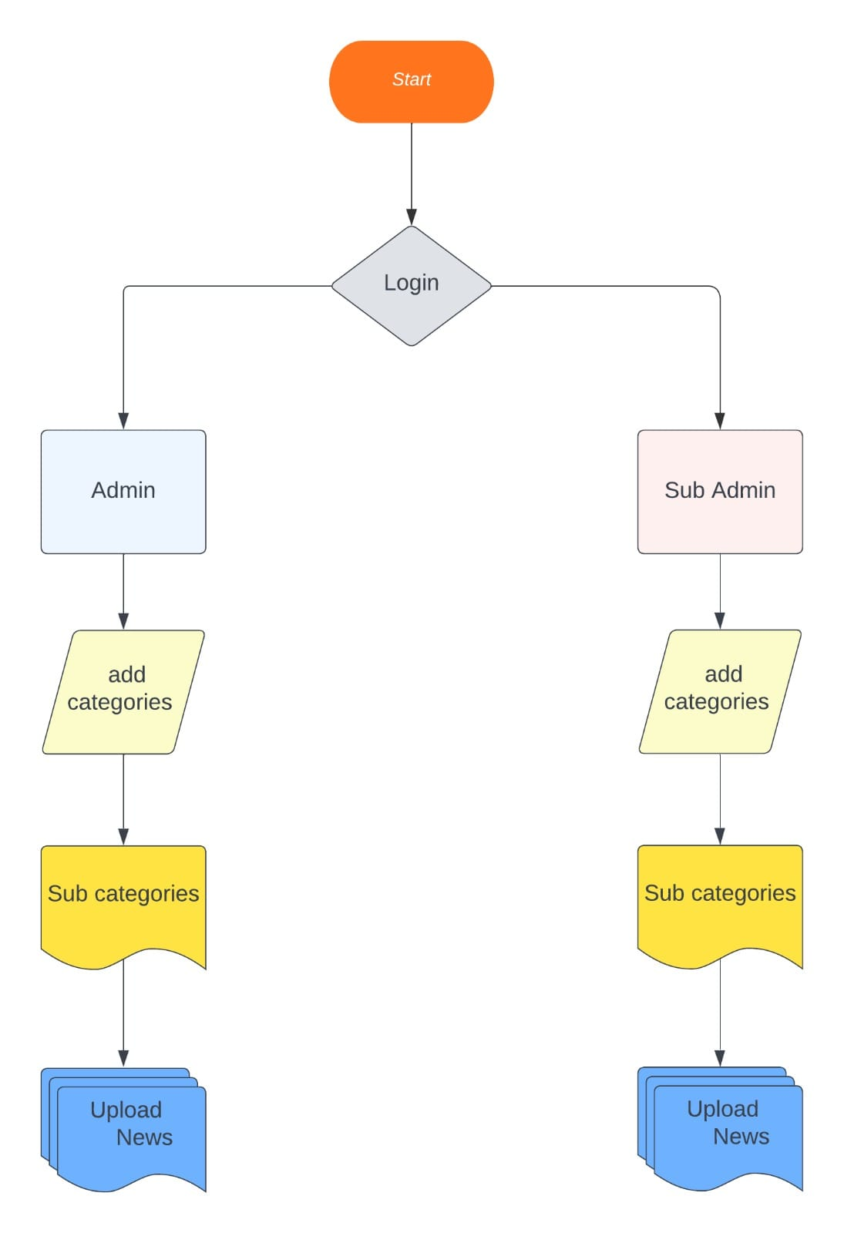

**Figure :1 Flow chart**

**5.1 Entity-Relationship Model**

Simply stated the ER model is a conceptual data model that views the real world as entities and relationships. A basic component of the model is the Entity-Relationship diagram which is used to visually represent data objects. Since Chen wrote his paper the model has been extended and today it is commonly used for database.

**Basic Constructs of E-R Modeling**

The ER model views the real world as a construct of entities and association between entities.

**Entities**

Entitiesare the principal data object about which information is to be collected. Entities are classified as independent or dependent (in some methodologies, the terms used are strong and weak, respectively). An independent entityis one that does not rely on another for identification. A dependent entityis one that relies on another for identification.

**Relationships**

A Relationship represents an association between two or more entities. Relationships are classified in terms of degree, connectivity, cardinality, and existence.

**Attributes**

Attributesdescribe the entity of which they are associated. A particular instance of an attribute is a value. The domain of an attribute is the collection of all possible values an attribute can have. The domain of Name is a character string.

**Classifying Relationships**

Relationships are classified by their degree, connectivity, cardinality, direction, type, and existence. Not all modeling methodologies use all these classifications.

**Degree of a Relationship**

The degree of a relationship is the number of entities associated with the relationship. The n-ary relationship is the general form for degree n. Special cases are the binary, and ternary, where the degree is 2 and 3 respectively.

**Connectivity and Cardinality**

The connectivity of a relationship describes the mapping of associated entity instances in the relationship. The values of connectivity are "one" or "many". The cardinality of a relationship is the actual number of related occurrences for each of the two entities. The basic types of connectivity for relations are: one-to-one, one-to-many, and many-to-many.

**Direction**

The direction of a relationship indicates the originating entity of a binary relationship. The entity from which a relationship originates is the parent entity; the entity where the relationship terminates is the child entity.

The direction of a relationship is determined by its connectivity type .An identifying relationshipis one in which one of the child entities is also a dependent entity. A non-identifying relationshipis one in which both entities are independent.

**Existence**

Existencedenotes whether the existence of an entity instance is dependent upon the existence of another, related, entity instance. The existence of an entity in a relationship is defined as either mandatory or optional.

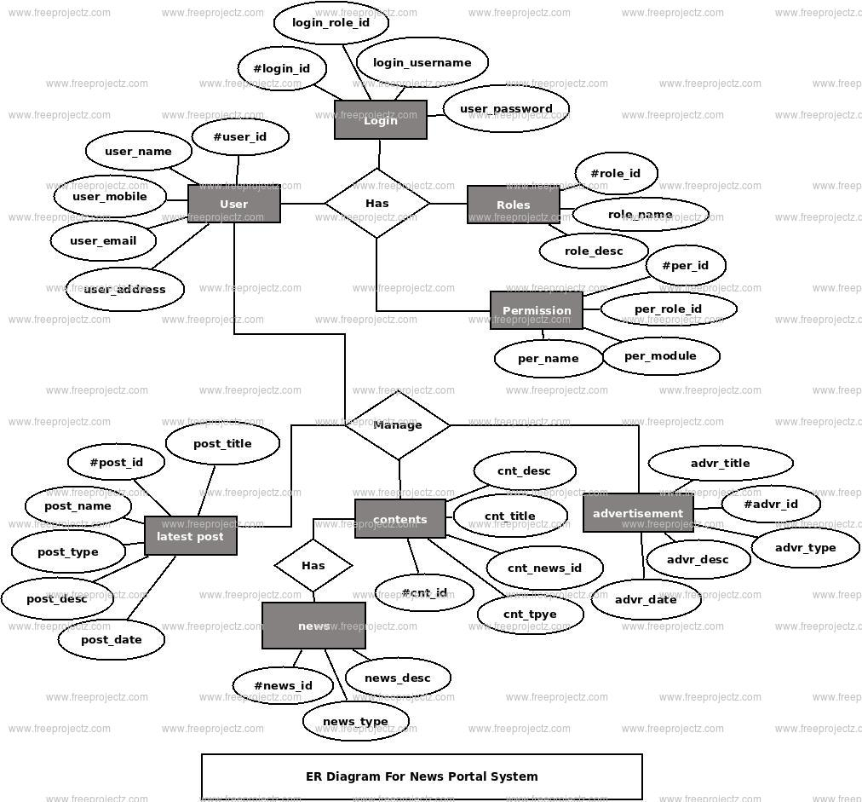

**Figure 2: ER Diagram**

**6.Software System Attributes**

**6.1 Reliability:**

* The system should operate consistently and reliably without unexpected errors or failures.
* It should be able to handle high loads and maintain performance under various conditions.

**6.2 Availability:**

The system should be available to users as per the defined service level agreements (SLAs).

It should minimize downtime and provide a high level of uptime.

**6.3 Security:**

The system should implement robust security measures to protect user data and ensure confidentiality.

It should have mechanisms to prevent unauthorized access, data breaches, and other security threats.

**6.4 Maintainability:**

The system should be designed to be easily maintainable and modifiable.

It should allow for efficient bug fixing, updates, and enhancements without disrupting the overall functionality.

**6.5 Portability:**

The system should be designed to be portable across different environments, platforms, and devices.